##### Quiz Management System

##### A PROJECT REPORT

###### ***Submitted by:***

##### Priyanka Mishra(Team Leader)

**Mohd Imran**

**Mansi Srivastava**

**AshishSethi**

**List of Figures**

-User login

-Registration

-Dashboard

-Quiz

-Login

**Document Purpose**

Quiz Management web portal personalized to meet all requirements of students of different fields at a single platform, which would help to test our knowledge and would be accessible from any place of the world. E-Study portal can be defined as a portal that helps to test ourperformance and assessment.

Gripping of subject, knowledge about real world facts, familiarity with the real time problems and solutions are the key ways to cope with above challenges. This portal is enacting as a bridge of communication amongst students of

different fields and different colleges.

**OBJECTIVES**

We used a combination of surveys, focus groups, and one on-one interviews to gather information from students, faculty, and from key personnel at other institutions. After gathering requirements we have decided the following aims and objectives of Quiz Management System:

1. Make a user-friendly portal.

2. To provide anytime/ Anywhere Online Assessment.

3. Enabling knowledge sharing.

4. Easy for students to use and customize. .

5. Easily accessible from any corner of the world if you have internet connection.

**Login**

In User Login. The user will login and will be able to access the web application.

* Email – Id
* Password

**Registration**

If user is accessing the web application for the first time then the user will have to register themselves by providing the following details.

* Name
* Age
* Gender
* Contact Number
* Email Address
* Password

**Modules and functionality**

The system functions can be described as follows:

* **Registration:** When the user enters the page, they have to register and then new users are added to the database.
* **Login:** When Email Id and password is matched it allows the user to dashboard or else it denies the user to enter into website

**Login Module**

|  |  |
| --- | --- |
| **Email Address**  **Password** | **Textbox**  **Textbox** |

**Registration Module**

|  |  |
| --- | --- |
| **Name**  **Age**  **Contact Number**  **Gender**  **Email Address**  **Password** | **Textbox**  **Textbox**  **Textbox**  **Radio Box**  **Email**  **Textbox** |

**Technology Used- ASP .NET MVC**

**SQL Table-**

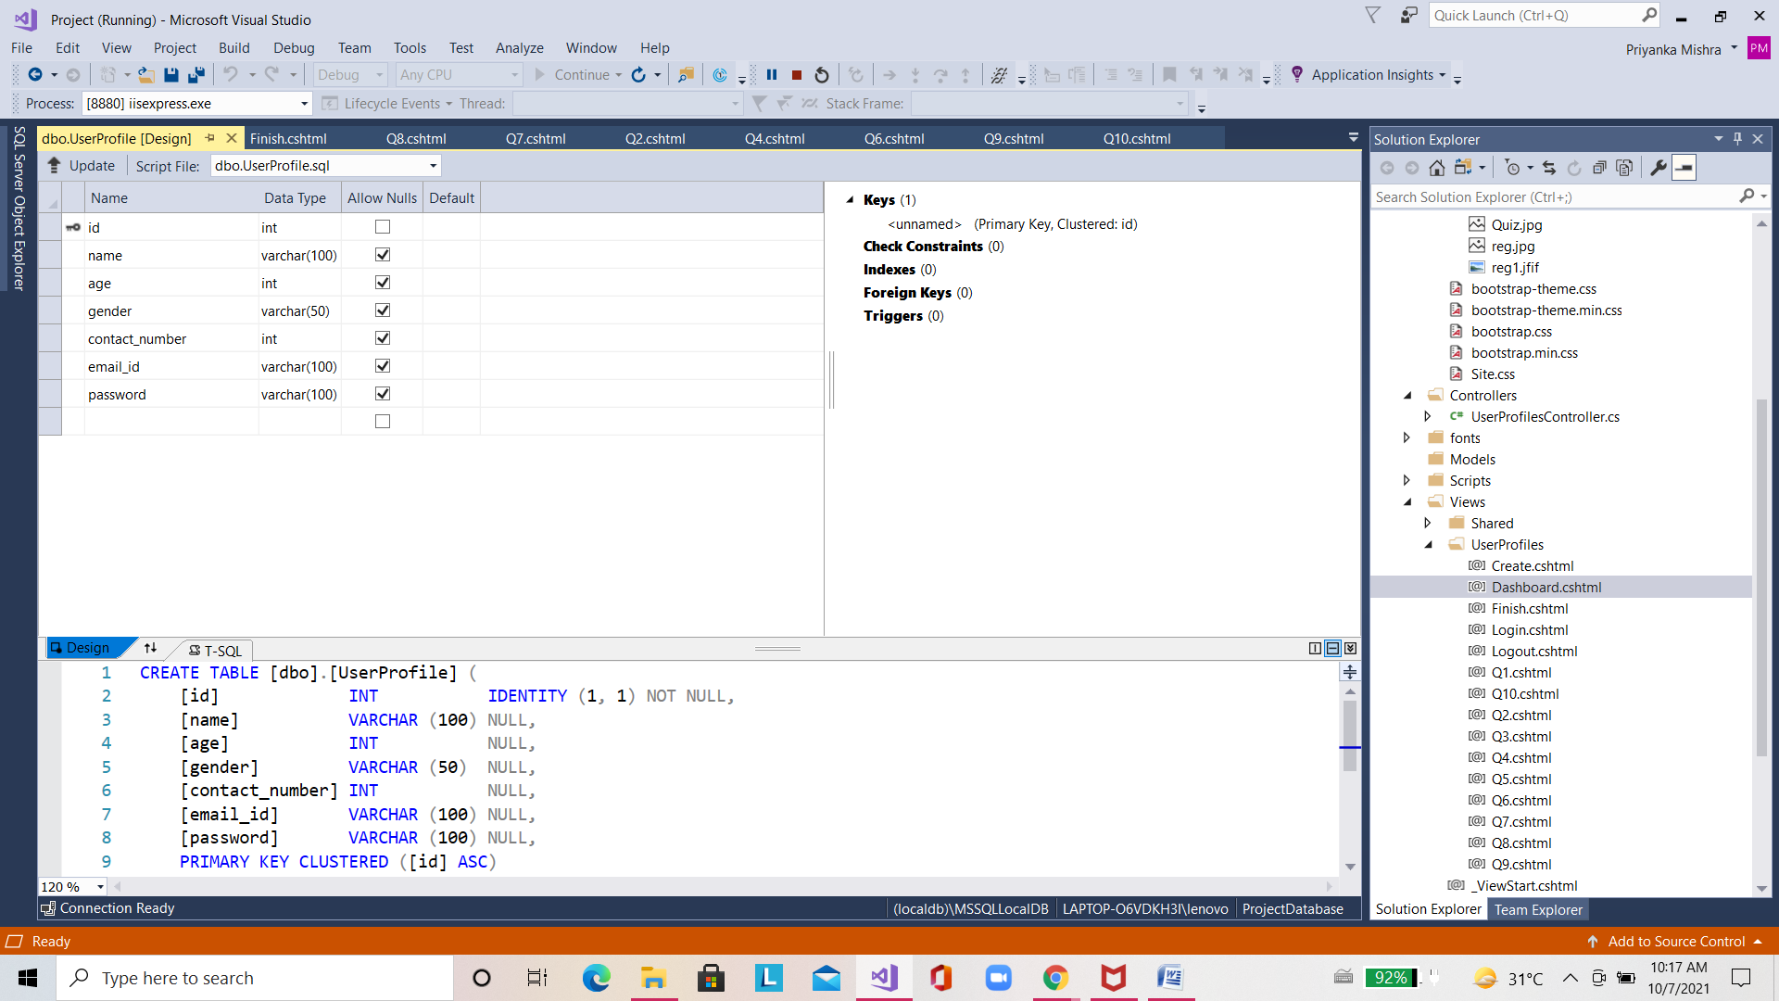

Thank you…